Hospital Caterers Association
Leadership & Development Forum 2023
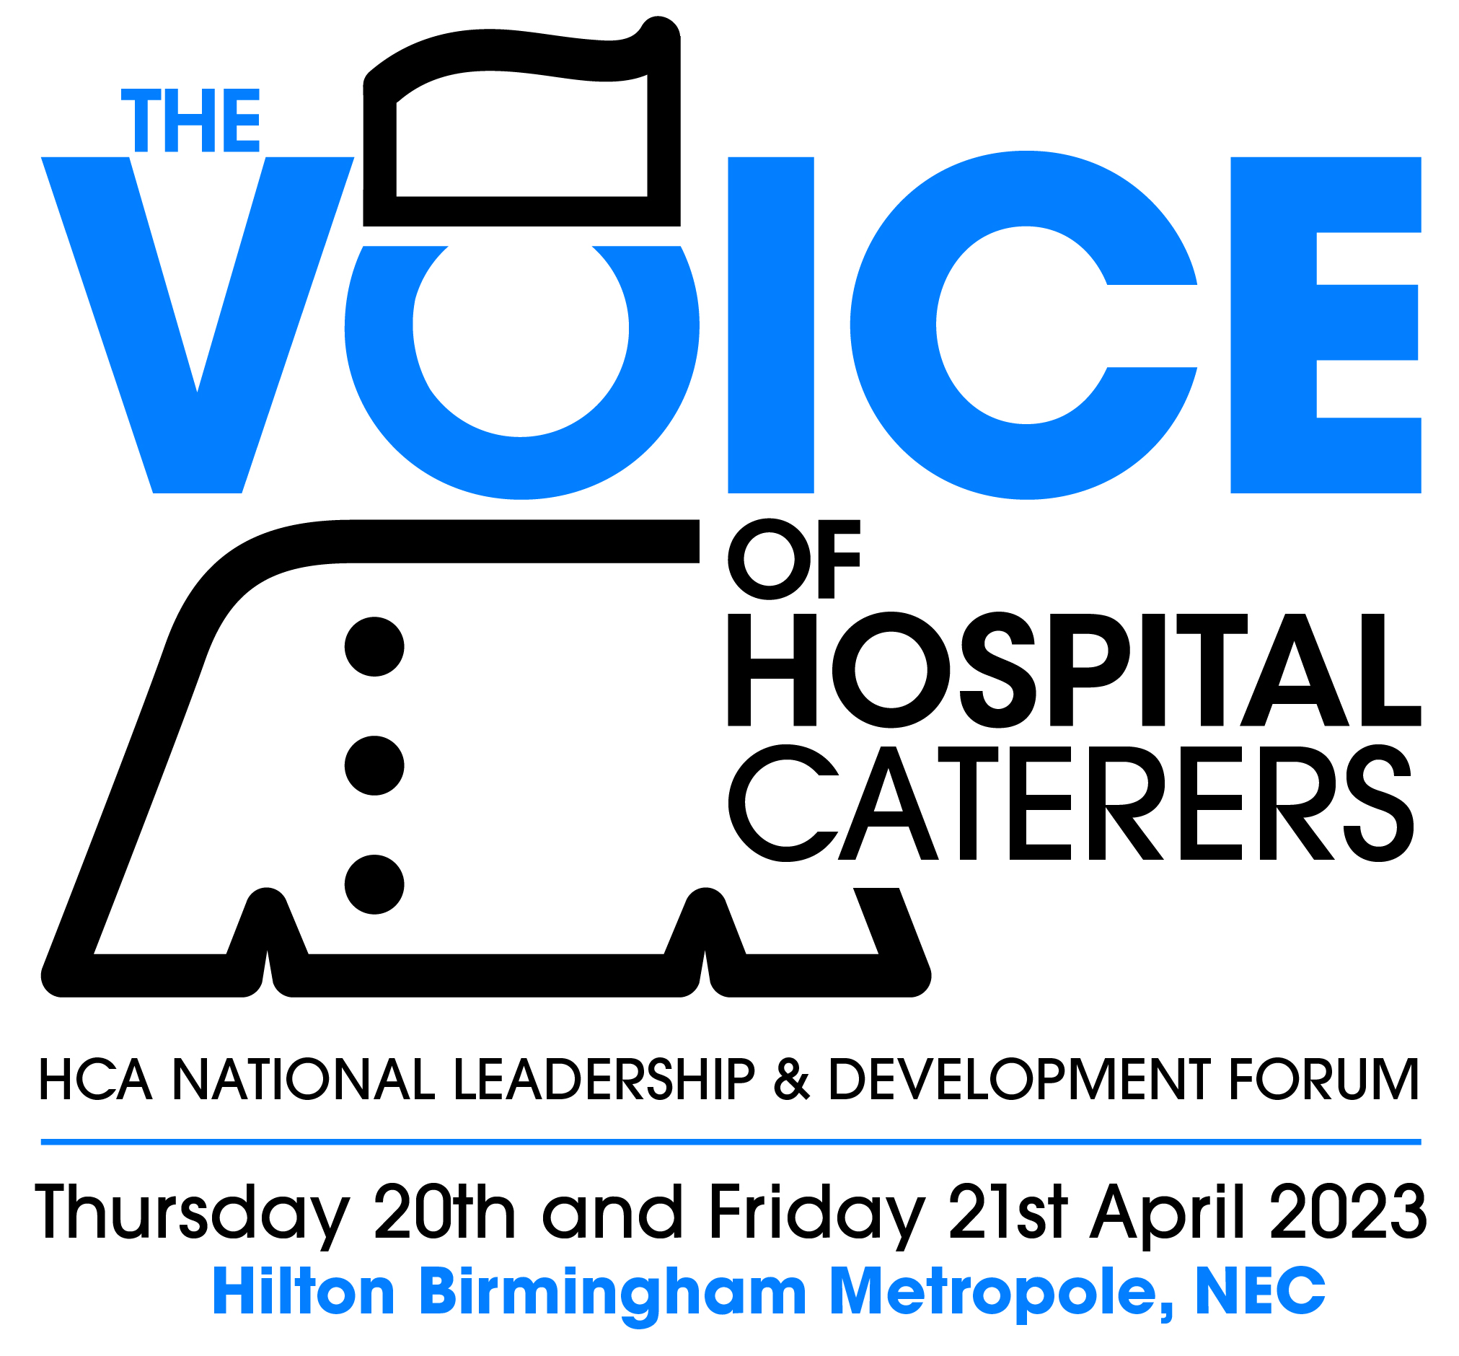

Hilton Birmingham Metropole
Wednesday 19th – Friday 21st April 2023

DELEGATE JOINING INSTRUCTIONS

Forum Venue
The HCA Leadership and Development Forum 2023 will take place at Hilton Birmingham Metropole Hotel, Pendigo Way, Birmingham B40 1PP. Please use this postcode for Satnav guidance to the venue; a venue map is also included in the covering email.

Accommodation
If your booking includes accommodation, this will be at the Hilton Birmingham Metropole hotel. Bookings are now confirmed and we cannot accept cancellations or offer a refund on cancelled accommodation but we can allow substitutions up to the date of arrival. Any name changes should be made in writing. Guests are personally responsible for settling accounts for telephone calls, newspapers and other personal expenses before leaving the hotel.

Car Parking
Please note that parking is not included in the delegate fees. The parking rate for residential delegates is £10 per day, for day delegates the rate is £12 per day. You are advised to pre-book parking, although please note this does not guarantee availability, using the following link and codes to get these rates:

Parking || Hilton Birmingham Metropole (bhmparking.co.uk)

Car Parking Code: KLJTK - Day delegates ITEPF – Residents

Alternatively you can pay for parking using the machines in the hotel lobby as you leave the hotel.

Delegate Registration
The Delegate Registration Desk will be open at the following times and locations:
Wednesday 19th April - 2pm and 5pm – the registration desk will be in the main hotel foyer

On Thursday and Friday, the registration desk will be in the Monarch Foyer so please use the entrance to the Monarch Suite from the hotel car park
Thursday 20th April – 8.30am and 12midday.
Friday 21st April –8.30am and 10am

Delegate badges
Badges must be collected on arrival from the registration desks. Delegates who have Friday’s Forum sessions included in their booking will have a green stripe on their badge. Delegates with a black stripe on their badge haven’t added the Friday Forum sessions to their booking so will be welcome to attend the exhibition but won’t be permitted into the Forum sessions when these resume or have lunch on Friday. Please refer to your booking confirmation to see what day’s Forum attendance you are booked in for – if you wish to add a day delegate place on Friday to your booking, email hcaforum@dewberryredpoint.co.uk or call 0845 018 5504, the cost of this is £125 + VAT.

Lanyards
The lanyards are intended to be recycled for future use at the end of Forum. Please either take your lanyard with you and bring it again if you attend in 2024 or leave it in the box provided outside the main Forum room when you depart.

Forum Sessions
All Forum sessions will be held in the Kings Suite at Hilton Birmingham Metropole. The dress code for Conference sessions is relaxed business dress. The programme can be found here https://hcaforum.co.uk/9/programme

Workshop Sessions
The Friday morning workshop sessions will be held in the Norfolk, Dorset and Surrey Rooms at the Hilton Birmingham Metropole. Your badge will denote which workshop room you should go to. Delegates will remain in their allocated room for the workshop sessions, the speaker panels will move rooms to deliver each of the sessions. Refreshments will be available.

Exhibition
The Exhibition will be held in the Monarch Suite at the Hilton Birmingham Metropole. The exhibition opens each day at 8.30am, please refer to the programme for the full schedule of opening times. Click here to view the exhibitor list, a floorplan is attached to help you plan your time in the exhibition.

Please take time to visit as many stands as possible to acknowledge the generous support these companies have given to the Leadership & Development Forum this year

Delegate Incentive Scheme
Delegates have the opportunity to win a prize by visiting and collecting stickers from selected exhibition stands. Full details will be inside the Incentive Scheme Entry Form, which will be given to you on arrival in your delegate pack. The draw will take place in the exhibition at 1.30pm on Friday 21st April.

Networking Event – Wednesday afternoon
For delegates arriving on Wednesday, the South West branch would like to invite you to afternoon tea, being served in the Warwick Suite between 3.30pm and 5pm.
This is an informal networking session with 30 of the exhibitor companies attending for you to make initial introductions and set up a time to meet on their stand. There is no schedule to work to so please feel free to join the exhibitors when you arrive on Wednesday afternoon.

Breakfast and Lunch
For residential delegates, breakfast will be served in the main hotel restaurant.

Refreshments and lunch for delegates on Thursday and Friday will be served from buffet points in the Monarch Suite.

Wednesday night – informal dinner
If you have booked accommodation with us for Wednesday 19th April, this will include a place at the informal networking dinner which will be held in the Kings Suite at the Hilton Birmingham Metropole. The evening starts at 7.30pm – there will be drinks on the tables and a street food buffet meal. We are pleased to advise that Jay’s Pub Quiz, which became an online must-join during the Covid lockdown, will be held during the evening with a prizes for the winning and runner up tables.

President’s Dinner
The President’s Dinner will take place in Kings Suite at the Hilton Birmingham Metropole on Thursday 20th April. The evening will commence at 7pm with a drinks reception in the Westminster Suite, dinner will be called at 7.30pm for an 7.45pm start. The dress code is black tie for men, cocktail or evening dresses for ladies.

HCA Awards
The HCA Awards will be presented during the President’s Dinner. Delegates are politely reminded to refrain from talking during this time. The cash bar service will be closed during the awards presentations.

Branch Charity and Raffle
The South West FMT are raising money for the RNLI. During the President’s Dinner there will be a raffle for the Charity with a selection of prizes donated by the branches of the HCA and the HCA Exhibitors. Tickets are priced at £10 each and payment can be made by cash for preference; there will be an opportunity to leave an IOU which will be followed up the week after Forum for you to make your donation via BACS transfer to the charity direct.

Branch Dinner
The Branch Dinner will take place in the Kings Suite at the Hilton Birmingham Metropole on Friday 21st April.. The evening will commence at 7pm with a drinks reception in the Kings Suite dinner will be called at 7.45pm for an 8pm start The theme is a West Country Boardwalk with a donkey derby race game and side stall games open during the drinks reception and after dinner plus a band and DJ after dinner. The dress code is smart evening holiday wear.

Branch Photographs
The official Forum photographers are Creative Camera. They will be taking photographs prior to the President’s and Branch Dinners – branches, teams and individuals can pre-book their slot either in advance of the forum or at the registration desk on the first day. Please email hcaforum@dewberryredpoint.co.uk to pre-book your photo slot.

